The International Council for the Exploration of the Sea (ICES) offers courses led by high-profile scientists and instructors. Visit the Training web page: www.ices.dk/training.

Ecosystem Modelling for Fishery Management
Context and level
As we move toward ecosystem approaches to fisheries it becomes increasingly important to address strategic questions that cannot be answered using the more tactical single-species assessment. Examples include trade-offs between fisheries due to food web interactions, evaluating potential impacts of MPAs, and predicting how climate change will impact ecosystem fish production and future fisheries from ecological, social, and economic perspectives.
The course will provide an introduction to using ecosystem modelling for strategic evaluations as part of fishery management. It includes,
- a review of ecosystem model types;
- an overview of food web modelling and integration with fisheries economics;
- time-dynamic modelling with emphasis on time series fitting and environmental impacts
- ecosystem carrying capacity, and trade-offs between fisheries;
- ecosystem-level management strategy evaluation;
- spatial modeling including habitat capacity modeling, fleet-effort dynamics, MPA evaluation, and spatial optimization (zoning); and
- an introduction to using ecosystem modeling in regional management councils;
The course will be split about evenly between lectures and tutorials, with a focus on hands-on development of simple models from scratch. The intention is to give participants confidence in constructing and interpreting basic ecosystem models, as well as a basic knowledge of more advanced methodologies for modelling.
The course is intended for scientists with some prior experience with ecosystem modelling. The open source Ecopath with Ecosim (EwE) software will be used extensively for the course, and participants are expected to have at least a basic familiarity with the approach. Some preparation is therefore expected prior to arrival, notably reading through the course material and exploration of the software.

Course dates
26-30 August 2013

Training course materials
- EwE6 User’s Guide (download from www.ecopath.org)
- Reprints (will be made available to participants prior to the course)
- Lecture notes (will be made available to participants prior to the course)
- Presentations (will be made available to participants prior to and during the course)

Venue
International Council for the Exploration of the Sea
H. C. Andersens Boulevard 44–46
DK-1553 Copenhagen V
Denmark
Tel: (+45) 33 38 67 00
Fax: (+45) 33 93 42 15
Email: info@ices.dk
You can find more information about:
ICES HQ here
Hotels close to ICES here
The hostel next to ICES here

Organization
The course is organized by the ICES Secretariat as part of the ICES Training programme.
Villy Christensen and Steve Mackinson, who both have extensive experience with ecosystem modeling, will lead the course and provide course materials.
The course includes applied examples, case studies, and hand-on exercises on the computer.
Participants are required to bring their own laptops (Mac with virtualization is OK) to connect to the ICES network, and also to have EwE (freely downloadable from www.ecopath.org) installed prior to arrival.

Admission and registration
The course is designed for a maximum of 25 participants. The working language is English.
The deadline for the submission of applications is
7 June 2013. Please use the online registration: http://www.ices.dk/iceswork/training/registration/

Fee
The fee for the course is 750 €. This covers only the tuition fee.

Programme
The five-day course is arranged with a series of lectures introducing concepts and implementation, followed by hands-on sessions in which the participants explore the various modules and approaches in EwE, based on simple ecosystem models constructed during the course. For details, see the preliminary program below.

Instructors
Villy Christensen, Professor
Fisheries Centre, University of British Columbia
2202 Main Mall, Vancouver BC, Canada V6T 1Z4
Tel: (+1) 604 822 5751
v.christensen@fisheries.ubc.ca

Steve Mackinson, Team Leader
Ecosystem Applications, CEFAS
Pakefield Road, Lowestoft
Suffolk, NR33 0HT UK
Tel: (+44) 1502 524295
steve.mackinson@cefas.co.uk

Contact ICES Secretariat for more information
Coordinator for Training
Tel: (+45) 33 38 67 52
Email: training@ices.dk

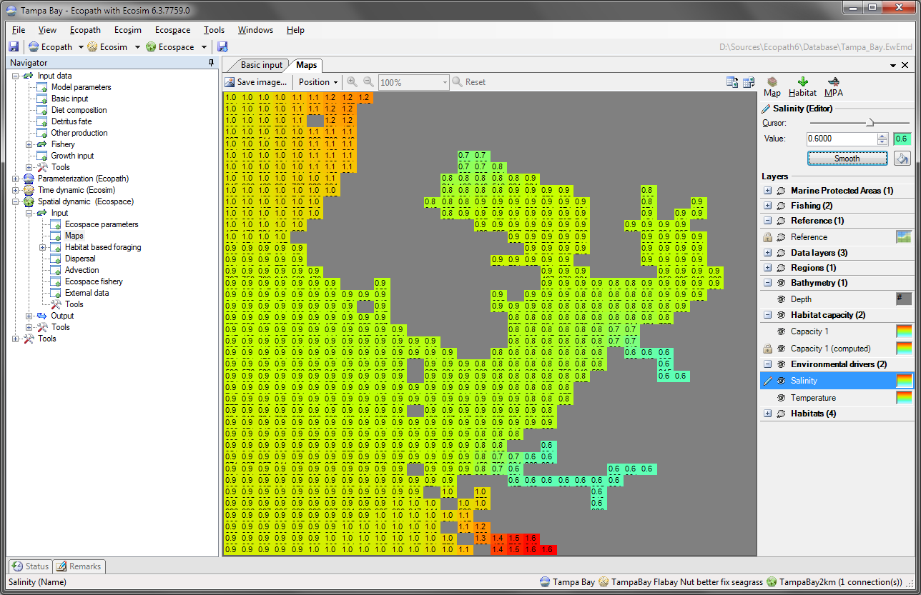

Day 1 | Topic (program may be modified during course)
Morning (9.00) | Welcome to ICES Training Programme (ICES Coordinator for Training)  About ICES, services, advice and practical issues (ICES representative)  About this course (Villy Christensen and Steven Mackinson)  Introduction of participants and lecturers, expectations  Lecture: Ecosystem models: types and characteristics  Lecture: Introduction to EwE, the approach and software
Afternoon | Tutorial 1: Build and parameterize a simple food web model  Lecture: Mass-balance modelling; introduction; parameters  Tutorial 2: Mass-balancing of simple ecosystem models  Lecture (time permitting): Network analysis, indicators, model comparisons
Day 2
Morning | All days will start with a summary of the previous day  Lecture: Modelling predator–prey interactions; time-dynamic modelling; the foraging arena: density-dependence and carrying capacity. Modeling environmental impact. Primary production anomalies. Using climate drivers.  Tutorial 3: Introduction to time dynamic modeling
Afternoon | Lecture: Time series fitting. Mediation: modeling non-trophic impacts.  Tutorial 4: Fitting ecosystem models to time-series data
Day 3
Morning | Tutorial 5: Model fitting and performance testing: the North Sea  Lecture: Fishing policy exploration. Defining objectives for management  Tutorial 6: Fishing policy exploration: the North Sea
Afternoon | Lecture: Modeling economic and social aspects of the fisheries sector  Lecture: Management Strategy Evaluation, modelling multispecies fishery regulations (weakest stock, strongest stock with discarding, selective fishing quota); fleet quotas; target fishing mortality policy. Fleet size dynamics  Tutorial: Management Strategy Evaluation and fishery regulations
Day 4
Morning | Summary of model fitting, policy exploration, and MSE  Lecture: Building modules for analysis and data extraction  Tutorial 7: The CEFAS Data-extractor  Spatial modelling in EwE; introduction; habitat capacity, spatial data; objectivity function; optimizations; linkages to Marxan; comparative studies  Tutorial 8: Defining, setting up and running a spatial model
Afternoon | Lecture: Application of spatial modeling in fisheries and conservation. Using ecosystems models for fishery management: North Sea models; use in regional management councils; policy questions and objectives  Tutorial 9: Exploring the North Sea models
Day 5
Morning | Lecture: Linkages to other models, alternative modelling approaches within modelling frameworks. End-to-end modeling: On coupling models  Tutorial 10: Your own models: issues and solutions  Evaluation (written)
Afternoon | Lecture: The future of ecosystem modeling. Using EwE as a decision-support system  Closing (16.00)

The course fee for participants from non-ICES member countries is 1250 €

